IMMUNICARE
Child Vaccination Management System
Final Project Documentation
Current-code edition • Version 1.0 • 27 September 2026
Prepared for final project submission
Project report, operational flow, database design, testing and handover details

Certificate of Completion
This is to certify that the project titled “ImmuniCare — Child Vaccination Management System” has been developed and documented as a PHP/MariaDB web application for managing child vaccination appointments, schedules, records and supporting administration.
The project is submitted for academic evaluation. Names, registration numbers, institution and supervisor details should be completed by the submitting group.
Field | Details
Student / Group | ____________________________________________
Batch / Class | ____________________________________________
Institution | ____________________________________________
Supervisor | ____________________________________________
Submission date | 27 September 2026
Supervisor signature | ____________________________________________

Table of Contents
1. Project Overview and Problem Definition
2. Customer Requirement Specification
3. Project Plan
4. E-R Diagrams and Database Design
5. Algorithms and Current Business Flow
6. GUI Standards Document
7. Interface Design Document
8. Task Sheet
9. Project Review and Monitoring Report
10. Unit Testing Checklist
11. Final Checklist and Handover
Appendix A. Login, Database and Deployment Credentials
Appendix B. Scope Limitations and Source References
Accuracy note: this report describes the current source tree and migration set. The two presentation files named in the request were not available at their stated Downloads paths, so repository code, schema, demo guide and test report were treated as authoritative.

1. Project Overview and Problem Definition
ImmuniCare is a role-based web system that coordinates Parents, Hospitals and Administrators in one child vaccination workflow. It replaces disconnected paper or informal processes with controlled child profiles, next-dose eligibility, hospital appointment slots, approval, scheduling, vaccination recording, notifications, inventory tracking and reports.

Problem definition
Vaccination information can be fragmented between Parents, hospitals and administrators. The project addresses this by keeping the child, dose, booking, schedule and final vaccination record linked, while enforcing ownership, availability, capacity and status rules.

Project objectives
- Provide secure login and separate dashboards for Admin, Parent and Hospital roles.
- Allow Parents to register children and request only the next eligible vaccine dose.
- Allow Hospitals to publish slots, approve requests, schedule visits and record outcomes.
- Maintain auditable vaccination history and transaction-safe vaccine consumption.
- Give Admin a central area for users, hospitals, vaccines, doses, inventory, reports and support messages.

Technology baseline
Layer | Current implementation
Application | PHP 8.2+; MySQLi; server-side sessions
Database | MariaDB/MySQL; InnoDB; utf8mb4
Client | HTML, CSS and vanilla JavaScript; responsive layouts
Security | Prepared statements, CSRF, role checks, password_hash/password_verify, secure session settings
Testing | PHPUnit, schema/integration tests, static checks and Playwright browser tests
Deployment | XAMPP local launcher or Docker Compose production setup

2. Customer Requirement Specification

Actors and permissions
Actor | Main responsibilities
Parent | Register/login; manage own children; view eligible vaccines; book, cancel or reschedule appointments; view schedules, history and notifications.
Hospital | Use portal after approval; create slots; approve/reject own bookings; schedule approved visits; record Vaccinated or Not Vaccinated outcomes.
Admin | sana.ahmed@immunicare.local
Public visitor | View home, vaccine catalogue, active hospitals, about, privacy and terms pages; submit a contact message.

Functional requirements
- Authentication must accept an active account only and redirect by role.
- A Parent can book only an unarchived child that belongs to that Parent.
- The system checks vaccine availability, dose eligibility, active hospital status, future slot availability and duplicate conflicts.
- A booking begins as Pending; Hospital action changes it to Approved or Rejected.
- Only Approved bookings can receive one vaccination schedule.
- A scheduled booking can produce one vaccination record; duplicate recording is rejected.
- Vaccinated consumes one unit of hospital inventory; Not Vaccinated does not consume stock.
- Notifications and audit records are created for important workflow actions.
- Admin reports support filtered on-screen results and CSV export.

Non-functional requirements
- Use prepared SQL statements and server-side validation.
- Protect POST actions with CSRF tokens and enforce server-side role/ownership checks.
- Keep medical history through archival rather than unsafe physical deletion.
- Use transactions for booking, scheduling and vaccination workflows.
- Keep production credentials outside source control and use HTTPS in deployment.

3. Project Plan
Phase | Deliverables | Status
1. Analysis | Problem definition, actors, workflow and data requirements | Complete
2. Database | Installer, migrations, foreign keys, constraints and seed/demo data | Complete
3. Foundation | Configuration, sessions, login, registration, CSRF and shared layout | Complete
4. Parent portal | Children, eligible doses, booking, bookings, schedules, history | Complete
5. Hospital portal | Slots, appointment decisions, schedules and vaccination records | Complete
6. Admin portal | Users, hospitals, vaccines/doses, inventory, reports and messages | Complete
7. Quality assurance | Static checks, unit/integration tests, route/security checks and browser tests | Implemented; DB run requires Docker
8. Documentation | Report, handover credentials, ER diagrams and final checklist | This document

Deployment sequence
- Copy setup/.env.example to setup/.env and replace all example passwords.
- Start either the XAMPP launcher or Docker Compose.
- Create/import vaccination_management_system using setup/database/install.sql.
- Apply numbered migrations through the migration runner; migration 005 creates repeatable demo data.
- Open the application and verify login, role routing and the core booking-to-record journey.
- Back up the database before production migrations or upgrades.

4. E-R Diagrams and Database Design
The diagrams below represent the current migrated schema. PK means primary key; FK means foreign key. The central operational chain is: users/children → vaccine dose → hospital slot → booking → schedule → vaccination record.
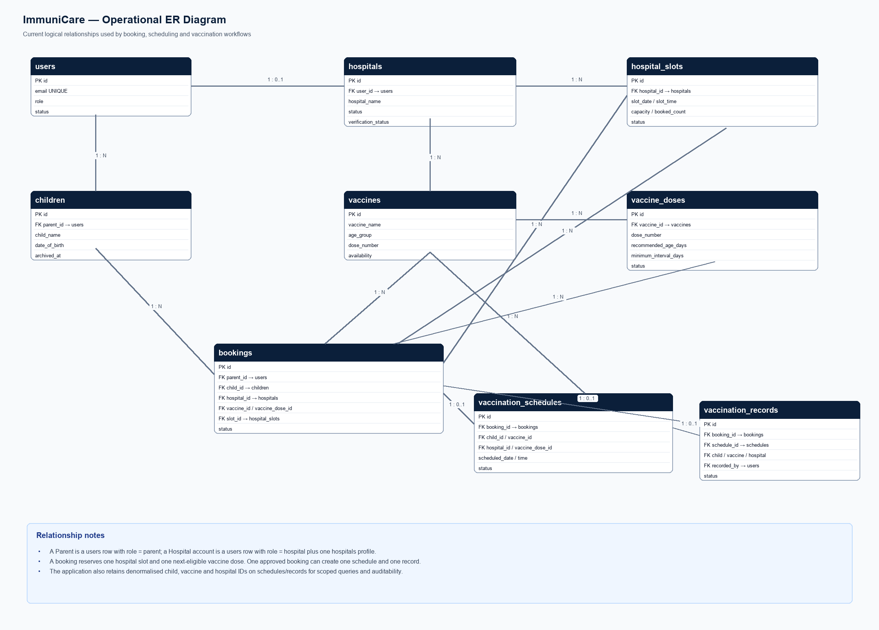
Figure 1. Core operational entities and relationships.

Schema groups
Group | Current tables
Identity and access | users, hospitals, api_tokens, email_verification_tokens, password_reset_tokens
Child and vaccine domain | children, vaccines, vaccine_doses
Appointment workflow | hospital_slots, bookings, vaccination_schedules, vaccination_records
Inventory and messages | hospital_inventory, inventory_transactions, notifications, notification_outbox
Administration and reporting | audit_logs, contact_messages, report_exports, schema_migrations

5. Algorithms and Current Business Flow

A. Login and role routing
- Receive email/password and verify the CSRF token.
- Load the user by email using a prepared query.
- Verify the password hash and require users.status = Active.
- Regenerate the session ID and store user ID, name and role.
- Redirect parent, hospital and admin users to their respective dashboards; reject wrong-role routes.

B. Next eligible vaccine dose
- Read Vaccinated records for the selected child and vaccine and find the highest completed dose.
- Select the next dose number from vaccine_doses.
- Require an Active dose and Available vaccine.
- Reject the dose if the child has not reached recommended_age_days.
- Reject the dose if minimum_interval_days since the last vaccination has not elapsed.
- Reject the dose when a Pending or Approved booking already reserves it.

C. Appointment booking
- Parent selects an owned child, an eligible dose and an open hospital slot.
- The server rechecks ownership, vaccine availability, active hospital status and future slot data.
- Lock the selected slot; reject a closed or full slot.
- Insert the booking as Pending, link vaccine_dose_id and slot_id, and increment booked_count.
- Create a hospital notification and audit event; roll back all changes if the transaction fails.

D. Hospital approval and scheduling
The Hospital can act only on its own Pending booking. Approve changes the booking to Approved. Reject changes it to Rejected and releases the reserved slot capacity. An Approved booking can receive one future vaccination schedule linked by booking_id, child, vaccine, dose and hospital.

E. Vaccination recording and inventory
- The Hospital selects an Approved booking with a Scheduled schedule; duplicate records are rejected.
- Insert a Vaccinated or Not Vaccinated record and update the schedule and booking in one transaction.
- Vaccinated → schedule Completed, booking Completed, lock inventory, require quantity ≥ 1, deduct exactly one, and write inventory_transactions.
- Not Vaccinated → schedule Missed, booking Cancelled, and do not change inventory.
- Notify the Parent and write an audit event; commit only when all required operations succeed.

F. Inventory warning
reorder_level is a warning threshold, not an automatic purchase. A hospital/vaccine row is flagged when quantity is less than or equal to reorder_level. Inventory is separate from the global vaccine availability flag.

Status transitions
Object | Current statuses / transitions
Booking | Pending → Approved or Rejected; Approved → Completed or Cancelled
Schedule | Scheduled → Completed, Missed or Cancelled
Vaccination record | Vaccinated or Not Vaccinated
Hospital | status: Pending/Active/Inactive; verification: Pending/Approved/Rejected
Slot | Open or Closed; capacity limits active bookings

6. GUI Standards Document
Standard | Current rule
Typography | Inter is the primary interface font; headings are larger and high contrast.
Primary colours | Navy #0B1F3A, blue #1E40AF / #3B82F6, light background #F5F7FA.
Semantic colours | Success #16A34A, warning #D97706, danger #DC2626; status badges use readable contrast.
Layout | Shared sidebar and portal header for protected areas; cards, tables and responsive content.
Forms | Visible labels, required fields, validation, CSRF hidden field on POST forms and clear feedback.
Navigation | Role-specific sidebar; public pages provide Home, About, Vaccines, Hospitals, Contact, Privacy and Terms.
Responsive behaviour | Layouts adapt for mobile widths; horizontal overflow is used for data-heavy tables.
Accessibility | Semantic headings, labels, button text, alert roles and keyboard-friendly modal interactions.

7. Interface Design Document
Interface | Inputs | Outputs / actions
Login | Email, password, CSRF | Role dashboard or generic error; forgot-password link
Parent dashboard | Navigation actions | Children, progress, appointments and notifications
My Children | Name, DOB, gender, blood group, address | Create/edit/archive child; ownership checked
Book Appointment | Child, eligible vaccine dose, slot | Pending booking; hospital notification
Hospital Slots | Future date, time, capacity | Open/closed capacity-controlled slots
Hospital Appointments | Approve/reject action | Booking status, slot release on rejection, Parent notice
Hospital Schedule | Future date/time | One schedule for an Approved booking
Hospital Vaccinations | Date, result, remarks | Record, status updates, inventory ledger and notice
Admin Inventory | Hospital, vaccine, quantity, reorder level | Current balance, warning state and ledger entry
Admin Reports | Report type and filters | On-screen results or CSV export

Main user journey
Admin configures hospitals, vaccine dose rules and inventory → Hospital creates open slots → Parent adds a child → Parent selects the next eligible dose and books a slot → Hospital approves or rejects → Hospital schedules an approved visit → Hospital records the outcome → Parent sees notification/history and Admin sees reports.
Current UI note: Dose schedule management is available in Admin/vaccine_doses.php from the “Vaccine Doses” menu and is also available inside Admin/vaccines.php under the “Dose schedule management” section.

8. Task Sheet
ID | Task | Evidence / location | Status
T01 | Secure authentication and role routing | login.php, includes/app.php | Complete
T02 | Parent child management | Parent/children.php; children table | Complete
T03 | Dose eligibility calculation | includes/workflows.php; vaccine_doses | Complete
T04 | Slot-based appointment booking | Parent/book_appointment.php; bookings/hospital_slots | Complete
T05 | Hospital approval/rejection | Hospital/appointments.php | Complete
T06 | Schedule and vaccination record | Hospital/schedule.php; Hospital/vaccinations.php | Complete
T07 | Inventory and audit ledger | Admin/inventory.php; inventory_transactions | Complete
T08 | Admin management and reports | Admin/*.php; reports.php | Complete
T09 | Public routes and contact support | index.php, contact.php, contact_messages | Complete
T10 | Automated QA and release checks | test_suite/tests and docs/TESTING.md | Implemented; DB execution pending environment
T11 | Final project report and handover | Project Documentation/ | Complete

9. Project Review and Monitoring Report

Completed review points
- The production application and test suite are separated into distinct directories.
- The database installer plus migrations define the current operational and supporting schema.
- Role and ownership checks are present in shared application helpers and portal pages.
- Booking, schedule and vaccination transactions preserve consistency when notifications or inventory operations fail.
- Static reports document PHP syntax, CSRF, route, security and responsive browser checks.

Open verification items before submission
- Run the full MariaDB/PHPUnit/Playwright Docker stack on a machine with Docker available.
- Complete a clean-install walkthrough using only disposable demo credentials.
- Replace certificate placeholders and confirm student/group details.
- Set strong deployment secrets, HTTPS and a least-privilege database user.
- Confirm clinical dose rules with an approved medical schedule before real-world use.

Known scope limitations
Production SMTP/email, SMS, WhatsApp, MFA, PWA offline synchronization and production monitoring are deferred integrations. Local in-app notifications, outbox records and local password-recovery previews remain available for testing.

10. Unit Testing Checklist
The repository test report records static checks and public browser smoke checks as passed. Database-dependent execution was blocked in the documented local environment because MySQL was unavailable; run it in the disposable Docker test stack before final submission.
Check | Expected result | Current evidence
PHP syntax | All PHP files parse | Passed in TESTING.md
CSRF audit | Detected POST forms include CSRF | Passed in TESTING.md
PDO scan | No PDO usage | Passed in TESTING.md
Route scan | No missing application targets | Passed in TESTING.md
Public browser smoke | Home/about responsive and accessible | Passed in TESTING.md
Dose eligibility | Age, interval, next dose and duplicate booking rules | PHPUnit tests present
Booking workflow | Ownership, slot capacity, conflict and rollback rules | PHPUnit tests present
Schema integration | Core tables and relations exist | Integration tests present
End-to-end portals | Parent → Hospital → Admin journey | Playwright test present; execute in Docker

Repeatable Docker test command
From /Users/tahir/Desktop/Wifi/vacine/test_suite:
docker compose up -d db app
docker compose run --rm test
docker compose run --rm browser
docker compose down -v

11. Final Checklist and Handover
- ☐ Complete source code is in Child Vaccination Management System/.
- ☐ Database installer is setup/database/install.sql; numbered migrations are in setup/database/migrations/.
- ☐ Demo data and demo account credentials are documented in Appendix A.
- ☐ Database backup/export is included separately in the final submission ZIP.
- ☐ setup/.env is not submitted with real secrets; submit setup/.env.example only.
- ☐ All login credentials used for evaluation are disposable and documented.
- ☐ The report, ER diagrams and testing evidence are included.
- ☐ Docker/XAMPP startup instructions are included.
- ☐ Certificate and student/institution fields are completed.
- ☐ Full database-dependent tests are run and results attached before submission.

Appendix A. Login, Database and Deployment Credentials

Application URLs
Environment | URL
XAMPP/local launcher | http://127.0.0.1:8080/index.php
Docker Compose | http://localhost:8080
Health endpoint | GET /api/v1/health.php

Local sample application accounts
These accounts are created by migration 005_demo_scenario_data.sql and renamed by migrations 006_karachi_sample_names.sql and 007_legacy_karachi_names.sql. Password for every account: TestPassword123! Use them only in a disposable local/demo environment.
Role | Email
Admin | sana.ahmed@immunicare.local
Parent 1 | ayesha.khan@immunicare.local
Parent 2 | muhammad.ali@immunicare.local
Hospital Alpha | aga.khan@immunicare.local
Hospital Beta | liaquat.national@immunicare.local

Local XAMPP database defaults
Setting | Value
Host | 127.0.0.1
Port | 3306
Database | vaccination_management_system
User | root (local XAMPP default only)
Password | Blank only when the local XAMPP root account has no password
Application timezone | Set APP_TIMEZONE explicitly; code fallback is Asia/Karachi

Docker database settings
Docker uses DB_NAME=vaccination_management_system, DB_USER=immunicare, DB_PASSWORD and DB_ROOT_PASSWORD from setup/.env, and the internal database host db. The values in setup/.env.example are placeholders and must be replaced; never use them as production secrets.

Installation commands
XAMPP/macOS: from the production project directory run ./setup/start-xampp.sh. Windows: run setup\start-xampp.bat. Docker: from setup/ run cp .env.example .env, edit the secrets, then docker compose -f docker-compose.production.yml up -d --build.

Credential handling
Passwords are stored as hashes. Do not place real passwords, setup/.env, database dumps containing private data, or API tokens in a public repository or final ZIP unless the evaluator explicitly requires a protected copy.

Appendix B. Scope Limitations and Source References

Authoritative project sources used
- Child Vaccination Management System/Project Documentation/explain.md — system guide and current workflow description.
- Child Vaccination Management System/Project Documentation/demo.md — demo journey and credentials.
- Child Vaccination Management System/setup/database/install.sql — base installer and migrated schema.
- Child Vaccination Management System/setup/database/migrations/001_harden_schema.sql through 007_legacy_karachi_names.sql, including both 003_workflow_integrity.sql and 003_reporting_preferences.sql.
- Child Vaccination Management System/includes/app.php and includes/workflows.php — shared security and business workflow helpers.
- test_suite/docs/TESTING.md and test_suite/tests/ — test evidence and automated checks.
- PHP - Vaccination Management System/Readme-Student Guide-eProject Process.txt — submission deliverables and final ZIP guidance.

Submission package recommendation
Create one ZIP named with batch, group and project title. Include the complete source code, this final report, a database backup/export, setup instructions, test evidence and any required screenshots. Exclude live secrets and replace all placeholders before submission.
Database table decision: The four unused support tables have now been removed from the clean installer and migrations. Migration 008 removes them from existing databases. The remaining schema supports the current Parent, Hospital, Admin, notification, recovery, API, inventory, audit, contact and reporting workflows. Back up an existing database before applying migration 008.

